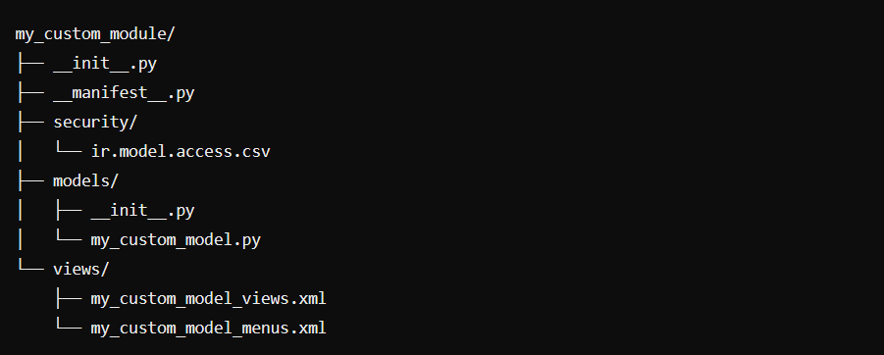

**1. my_custom_module/__init__.py**

This file initializes the module and imports the necessary Python files.



**2. my_custom_module/__manifest__.py**

This file defines the metadata for the module, including its name, version, dependencies, and data files.

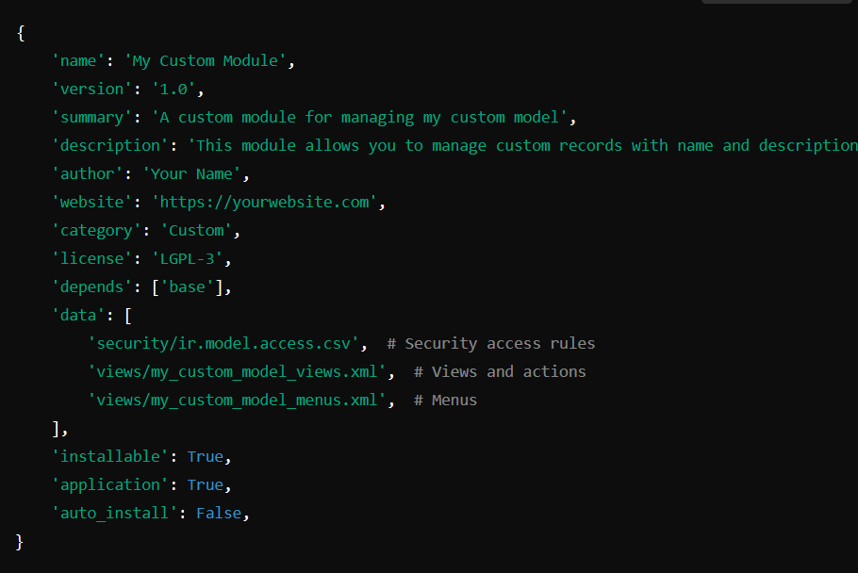

**Add sequnce to manage order of app in ui**

'sequence': -1,

**3. my_custom_module/models/__init__.py**



**my_custom_module/models/my_custom_model.py**

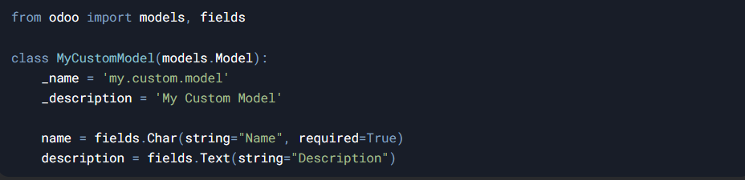

**4. my_custom_module/security /ir.model.access.csv**



* **id**: Unique identifier.
* **name**: Name of the access rule.
* **model_id:id**: The model (my_module.student).
* **group_id:id**: The group (base.group_user for normal users, base.group_system for managers).
* **Permissions**:
* **perm_read**: View records (1 = Yes, 0 = No).
* **perm_write**: Edit records.
* **perm_create**: Add records.
* **perm_unlink**: Delete records.

**5. my_custom_module/views/my_custom_model_views.xml**

This file defines the window action and views (tree and form).

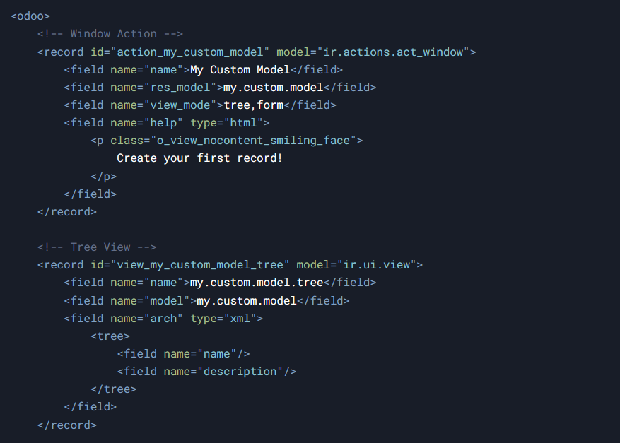

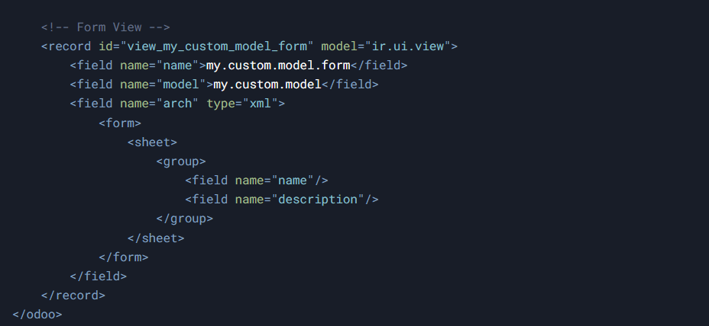

**6. my_custom_module/views/my_custom_model_views.xml**

This file defines the **menu items**.

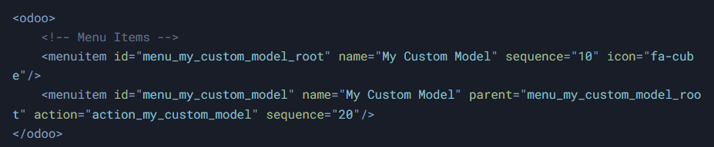

* **menu_my_custom_model_root:** The parent menu item.
* **menu_my_custom_model:** The child menu item that triggers the window action.
* **action:** The ID of the window action to execute.
* web_icon="crm,static/description/icon.png"
* <menuitem id="menu_root" name="OWL Module" web_icon="my_owl_module,static/description/icon.png"/>

**Explanation of the Module Structure**

**1. Root Directory**

* **__init__.py**: Initializes the module and imports the models directory.
* **__manifest__.py**: Contains metadata about the module, including dependencies and data files to be loaded.

**2. models/ Directory**

* **__init__.py**: Imports the model file to ensure it is loaded when the module runs.
* **my_custom_model.py**: Defines the my.custom.model model with fields and business logic.

**3. views/ Directory**

* **my_custom_model_views.xml**: Defines the tree and form views for the custom model, along with the window action.
* **my_custom_model_menus.xml**: Defines menu items and navigation for the custom model in the Odoo UI.

**4. security/ Directory *(NEW: Security Configuration)***

* **ir.model.access.csv**:
  + Defines access control rules for the custom model.
  + Specifies which users or groups can read, write, create, and delete records.
  + Uses a CSV format to declare access rights.